Test Function and shiny app

Suggestions for publication:

X considering the nature of the tool, displays of actual pictures will need to be made. Of course, not every available parameters and it option can be presented with screenshot (maybe a table listing them and their options but not screenshots). But to be able to show a few examples of the more aesthetical aspects of the plots, how about having one full picture on the left of a figure, that would harbour numerated red boxes in different areas, and on the right part, the same numbers and a zoom in on the box contents but with the different possibilities. For instance, a box on the sequencing track scale labelled 1 and on the side, number one and cropped version of the regular scale and scientific numbering scale side by side, thus allowing to show both without having the full picture.

X Specify to convert Bam to Bed for TIF-seq (using bamtobed from bedtools)

X annotations can be turned to bed too. For instance: Gff3 can be turned to Bed12 by using:
x gff3ToGenePred (makes a Gene Pred from gff3, almost instantaneous)
x genePredToBed (turns the gene Pred in a bed12, also almost instantaneous)
For GTF annotations, they can easily be converted to gff3

X The more plots you do the slower it gets (especially if you keep old plots opened) and the more memory R stats to take. Maybe specify that should a number of plot be performed, fully closing and restarting R might be needed.

N.B: all inputs were made from the shiny app, so even if the format of input reported bellow is not exactly written as it would for adding it directly to the function, the shiny app corrects it to the right format (if the arguments works fine)

General suggestion: would it be possible to have a way to scroll though the picture when the window is too small: in the example taken here the bottom of the plot could not be displayed due to the number of tracks. The PDF version allows to know that the plot is fine and is there, but it cannot be seen live. If possible, a scrolling would be good.

General Comment: when making warning messages relative to text inputs, specify that ‘spaces’ can be an issue, for instance after a colour name.

Currently: ‘bigwig_dirs’ and ‘colours’ are loaded from the environment and not from the function

Test 1-1 – Feature:

- import “test import 2”
- locus ‘GAPDH’
- all other parameters by default

Plot working (of note, display is too big and does not fit in screen, but previously tried to have it saved as PDF and the full plot was OK)

Test 1-2 – Feature:

- import “test import 2”
- locus ‘gap’ (with lower case + non existent
- all other parameters by default

return proper message saying that no locus is identified

Test2 – Coordinates:

- import “test import 2”
- coordinates “chr12:+:6532163:6539867” (correspond to the same ones as Gapdh)
- all other parameters by default

Plot working (also no error returned) but Header and genomic scale are not displayed

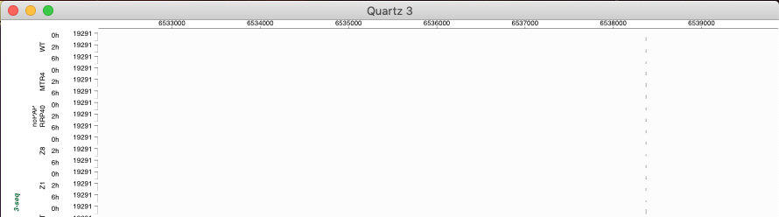

Test 3 – Scientific scale:

- import “test import 2”
- locus ‘GAPDH’
- Scientific scale used as ‘allow’, ‘all’, ‘none’
- all other parameters by default

All 3 works perfectly as intended

Test 4 – Deactivate usage of alternative background:

- import “test import 2”
- locus ‘GAPDH’
- alternative_background=FALSE
- all other parameters by default

Works perfectly as intended

Test 5-1 – Change colours of alternative background:

- import “test import 2”
- locus ‘GAPDH’
- bgr_colours=c("green","#FF0000")
- all other parameters by default

Works perfectly as intended

Test 5-2 – Change colours of alternative background:

- import “test import 2”
- locus ‘GAPDH’
- bgr_colours=c("green","#FF0000",’blue’) (does not respect described input format).
- all other parameters by default

Works perfectly as intended and ignores extra colors

Test 6 – no inputs at all:

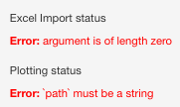

Errors are expected but maybe change the error message (N.B: due to the reactive nature of the shiny app, this is displayed by default at opening)

Test 7 – excel input but no Feature or locus specified:

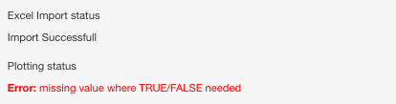

Errors is expected but maybe change the error message

Test 8 – Providing a wrong excel file:

Might need to figure this one out myself.

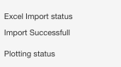

‘import successful’ message is for now only based on the fact a file is provided and errors are internal and not seen. Need to generate a message saying the input format is wrong.

Test 9 – Providing an input file that is not an excel:

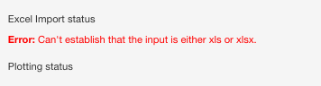

Error is expected and input is well restricted to excel but maybe make a more explicit error message.

Test 10 – binning value at 2000:

- import “test import 2”
- locus ‘GAPDH’
- bin_size = 2000
- all other parameters by default

Work as expected (somehow at to be read as ‘as.numeric’ in the function despite already being and ‘int’ but it works).

Test 11 – Bin start at 200:

- import “test import 2”
- locus ‘GAPDH’
- bin_start = 200
- all other parameters by default

Seems to work: a plot is returned without errors. Visually difficult to assess any difference

Test12-1 – Binning statistics for some seqtypes:

- import “test import 2”
- locus ‘GAPDH’
- setting of TT-seq to median and Meolas to max (samples also include RNA-seq and 3-seq, so specification does not cover all RNA-seq types)
- all other parameters by default

Seems to work: a plot is returned without errors. Visually difficult to assess any difference

Test12-2 – Binning statistics for all seqtypes as common parameter:

- import “test import 2”
- locus ‘GAPDH’
- setting of bin statistics as ‘max’ (should affect all seqtypes)
- all other parameters by default

Seems to work: a plot is returned without errors. Visually difficult to assess any difference

Test12-1 bis – Bins per cm at 1000:

- import “test import 2”
- locus ‘GAPDH’
- bins_per_cm=1000
- all other parameters by default

Seems to work: a plot is returned without errors. Visually difficult to assess any difference

Test12-2 bis – Bins per cm at 10000:

- import “test import 2”
- locus ‘GAPDH’
- bins_per_cm=10000
- all other parameters by default

Work: a plot is returned without errors.

Default (250)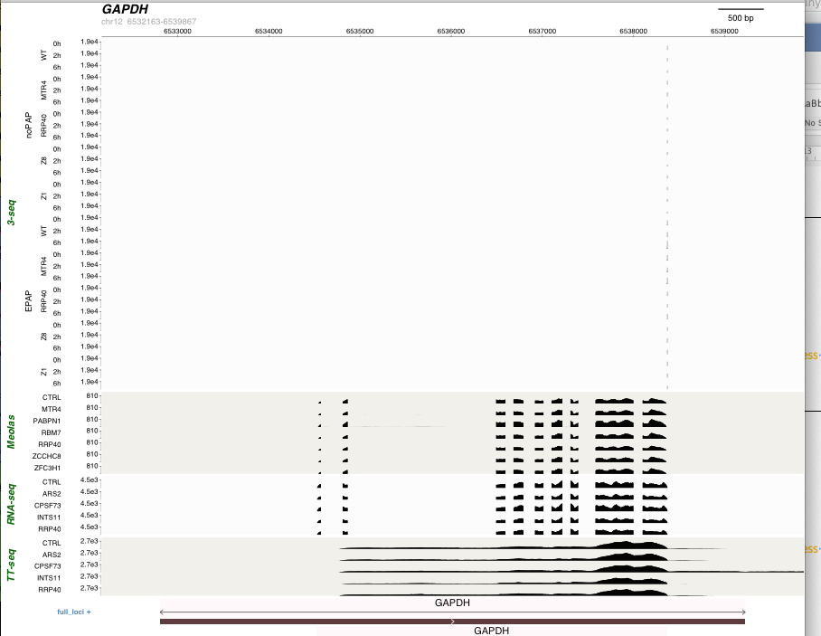

1000 (Widnes was similar, here the difference of display is due to the window display)
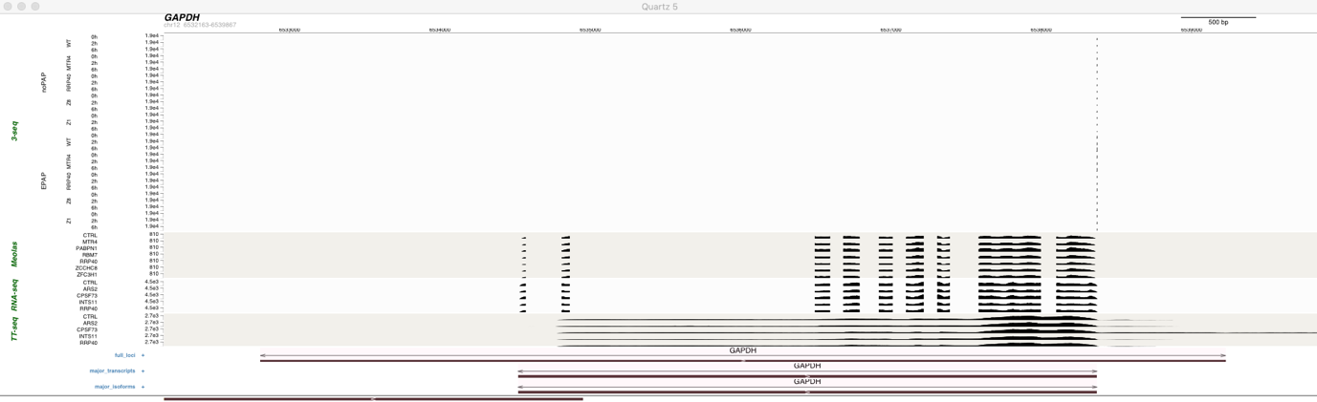

10000
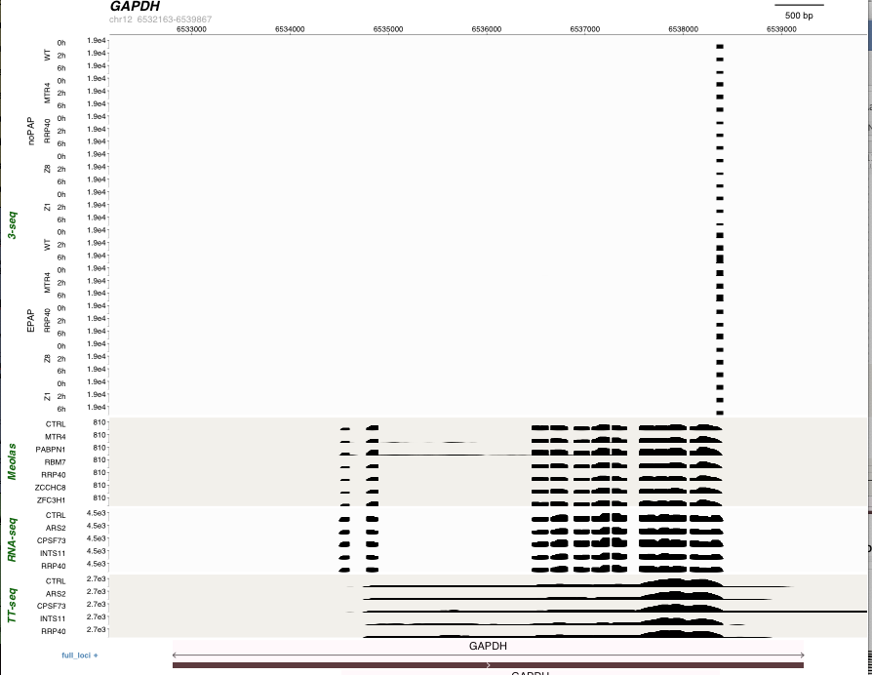

Test 13 – Select and rename annotation:

Test 13-1:

- import “test import 2”
- locus ‘GAPDH’
- selection of the annotation ‘full_loci’ and renaming it ‘The one’ but while calling it with a typo (in shiny: “The one:full loci”, lacking the underscore in the name)
- all other parameters by default

returns an error saying that the replacement has a length of zero which is due to the lack of match between the provided name and the actual name ( ‘else’ element and within, line 749 of the shiny app)
error is expected but make a warning message

Test 13-2:

- import “test import 2”
- locus ‘GAPDH’
- selection of the annotation ‘full_loci’ and renaming it ‘The one’ while calling it properly (in shiny: “The one:full_loci”)
- all other parameters by default

Works exactly as intended

Test 13-3:

- import “test import 2”
- locus ‘GAPDH’
- selection of the annotation ‘full_loci’ withtout providing a new name (thus not following the provided instructions)
- all other parameters by default

Same error as in 13-1 as expected. The warning message should account for both situations.

Test 13-4:

- import “test import 2”
- locus ‘GAPDH’
- keep all annotations but provide names in a different order (to check if it disturbs the function and/or can be used to reorder the annotations) than the excel sheet and give them names that are just numbers. Shiny input: “3:major_isoforms,1:full_loci:blue,2:major_transcripts”; while the excel order was full_loci, major_transcripts,major_isoforms.
- all other parameters by default

Plots works perfectly fine.
Using numbers as names is not an issue
order of annotations has been altered but not in the order provided here either:
Order In the excel | Order provided in the input | Order obtained
Full loci  Major transcripts  Major isoforms | Major isoforms  Full loci  Major transcripts | Full loci  Major isoforms  Major transcripts
Maybe add a control over order in the same argument

Test 14 – deactivate TUs name display:

- import “test import 2”
- locus ‘GAPDH’
- include feature names = FALSE
- all other parameters by default

Works perfectly as intended

Test 15 – Change annotation colours (full annotation, not biotype speicifc):

Test 15-1:

- import “test import 2”
- locus ‘GAPDH’
- annot_cols = blue
- all other parameters by default

Generates error: subscript out of bound which is expected as colour is not specified associated with an annotation name and does not respect the described input format. Maybe make an error message

Test 15-2:

- import “test import 2”
- locus ‘GAPDH’
- annot_cols = blue for full_loci (shiny input: full_loci:blue) , while there are two other annotations present and not specified here.
- all other parameters by default

Generates error: subscript out of bound which is expected as colour is not specified for the two other annotations and thus does not respect the described input format. Maybe make an error message

Test 15-3:

- import “test import 2”
- locus ‘GAPDH’
- annot_cols : shiny input: full_loci:blue ,major_transcripts:yellow,major_isoforms:red
- all other parameters by default

Works perfectly as intended

Test 15-4: similar to 15-3 but whit switching position of annotations names to validate that order does not matter

- import “test import 2”
- locus ‘GAPDH’
- annot_cols : shiny input: major_isoforms:red,full_loci:blue,major_transcripts:yellow
- all other parameters by default

Works perfectly as intended

Test 16-1 – Display Feature name below for the plus strand:

- import “test import 2”
- locus ‘GAPDH’
- feature_names_above=FALSE
- all other parameters by default

works perfectly as intended: name is under (and alternated for the minus strand as it is default parameters)

Test 16-2 – Display Feature name below for the plus strand – while deactivating the display of features names:

- import “test import 2”
- locus ‘GAPDH’
- feature_names_above=FALSE
- do not display features names
- all other parameters by default

works perfectly as intended (did not fall for my trap!!!)

Test 17-1 – Do not alternate the display of features names:

- import “test import 2”
- locus ‘GAPDH’
- feature_names_alternating=FALSE
- all other parameters by default

Works perfectly as intended

Test 17-1 – Do not alternate the display of features names – While displaying name bellow for the plus strand:

- import “test import 2”
- locus ‘GAPDH’
- feature_names_above=FALSE
- feature_names_alternating=FALSE
- all other parameters by default

Works perfectly as intended

Test 18-1 – annotations compaction:

- import “test import 2”
- locus ‘DHFR
- compaction= ‘expanded’
- all other parameters by default

N.B: since the annotations full_loci, major_transcripts and major_isoforms contain only one isoform each they are not the best to test these parameters. However, the argument comes in in the right format
seems to work as intended. To be further tested with other annotations

Test 18-2 – annotations compaction specified for only some of the annotations:

- import “test import 2”
- locus ‘DHFR
- compaction=” full_loci:expanded,major_isoforms:collapsed”
- all other parameters by default

N.B: since the annotations full_loci, major_transcripts and major_isoforms contain only one isoform each they are not the best to test these parameters. However, the argument comes in in the right format
seems to work as intended. To be further tested with other annotations

Test 19 – Do not display the loci highlighting arrows:

- import “test import 2”
- locus ‘GAPDH’
- incl_feature_brackets=FALSE
- all other parameters by default

Works perfectly as intended

Test 20 – Do not highlight features with colours:

- import “test import 2”
- locus ‘GAPDH’
- incl_feature_shadings=FALSE
- all other parameters by default

Works perfectly as intended

Test 21-1 – Specify two colours for the shading of loci:

- import “test import 2”
- locus ‘GAPDH’
- shading_colours (shiny input: green,#FF0000)
- all other parameters by default

Works perfectly as intended. The FF0000 correspond to very intense red and as the shading is done above (in term of layer) the loci, only red squares are seen. Either move the shading below the loci information (while keeping it above the background), or apply an opaqueness parameter by default

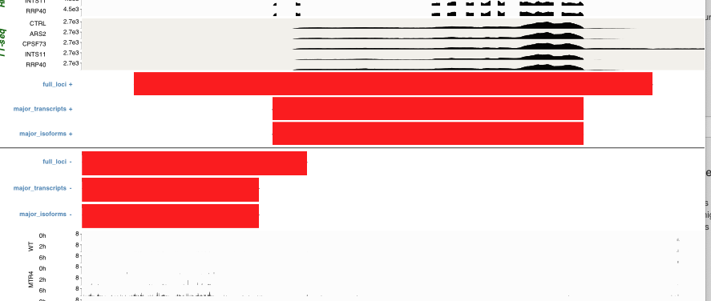

Test 21-1 – Specify only one colours for the shading of loci:

- import “test import 2”
- locus ‘GAPDH’
- shading_colours (shiny input: green which does not respect the provided instructions)
- all other parameters by default

does not display the shading but does not crash either. Very sturdy argument. Maybe add a warning.

Test 22 – Display using center of mass:

- import “test import 2”
- locus ‘GAPDH’
- Center of mass = TRUE
- all other parameters by default

Current annotations have only one isoform and therefore are not useful to test this parameter. Currently simply tried to ensure the lack of crash. Need to be further tested with other annotations.

Does not crash

Test 23 – Export as PDF:

- import “test import 2”
- locus ‘GAPDH’
- import as PDF = TRUE
- all other parameters by default

works perfectly as intended

Test 24 – Save PDF in a different directory:

- import “test import 2”
- locus ‘GAPDH’
- import as PDF = TRUE
- change of the folder to save to (desktop)
- all other parameters by default

works perfectly as intended

Test 25-1 – Save PDF in a different directory with a setup name:

- import “test import 2”
- locus ‘GAPDH’
- import as PDF = TRUE
- change of the folder to save to (desktop)
-change the name to a new one containing a special character (a ?)
- all other parameters by default

works perfectly as intended

Test 25-2 – Save PDF in a different directory with a setup name that already exist:

- import “test import 2”
- locus ‘GAPDH’
- import as PDF = TRUE
- change of the folder to save to (desktop)
-change the name to a new one containing a special character (a ?) in exactly the same place as before while the previous file is still there
- all other parameters by default

works perfectly as intended, adds V2 to avoid overwritting

Test 26-1 – Change of scaling factor:

- import “test import 2”
- locus ‘GAPDH’
- import as PDF = TRUE
- change of the folder to save to (desktop)
-change the name to a new one containing a special character (a ?) in exactly the same place as before while the previous file is still there
- change scaling factor to 2
- all other parameters by default

works but all the text are too big for the boxes. Maybe add a warning

Test 26-2 – Change of scaling factor:

- import “test import 2”
- locus ‘GAPDH’
- import as PDF = TRUE
- change of the folder to save to (desktop)
-change the name to a new one containing a special character (a ?) in exactly the same place as before while the previous file is still there
- change scaling factor to 0.2
- all other parameters by default

works perfectly as intended

Test 27 – Dummy plot:

- import “test import 2”
- locus ‘GAPDH’
- dummy plot = TRUE
- all other parameters by default

works perfectly as intended

Test 28-1 – Upstream distance:

- import “test import 2”
- locus ‘GAPDH’
- upstream distance at 0.3
- all other parameters by default

works perfectly as intended

Test 28-2 – downstream distance:

- import “test import 2”
- locus ‘GAPDH’
- downstream distance at 0.3
- all other parameters by default

works perfectly as intended

Test 28-2 – upstream and downstream distance:

- import “test import 2”
- locus ‘GAPDH’
- upstream distance at 0.3
- downstream distance at 0.3
- all other parameters by default

works perfectly as intended

Test 29 – plot width:

- import “test import 2”
- locus ‘GAPDH’
- plot width at 40
- all other parameters by default

works perfectly as intended

Test 30-1 – Track name space:

- import “test import 2”
- locus ‘GAPDH’
- track name space to 0.5
- all other parameters by default

Error: invalid value specified for graphical parameter "fig"
Line 2445 from the subfunction script

Test 30-2 – Track name space:

- import “test import 2”
- locus ‘GAPDH’
- track name space to 5.5
- all other parameters by default

Works perfectly as intended

Test 30-1 bis – Track name margin:

- import “test import 2”
- locus ‘GAPDH’
- track name margin to 0.025
- all other parameters by default

Seems to work, but difficult to see any difference with previous plots

Test 30-2 bis – Track name margin:

- import “test import 2”
- locus ‘GAPDH’
- track name margin to 0.5
- all other parameters by default

Perfectly works as intended (the difference can clearly be seen this time)

Test 30-3 bis – Track name margin:

- import “test import 2”
- locus ‘GAPDH’
- track name margin to 0.0000001
- all other parameters by default

Perfectly works as intended

Test 31 – Plot height:

- import “test import 2”
- locus ‘GAPDH’
- plot height at 10
- all other parameters by default

The plot indeed gets smaller, but it is still 24 cm total. The 10cm part is the one of the display of the plus strand tracks. Also, the names of the annotations, the coordinates and the genomic positions do not fit and are truncated. Maybe revisit to some extend the definition (user expecting a 10 plot will be surprised) and adjust the associated font size accordingly.

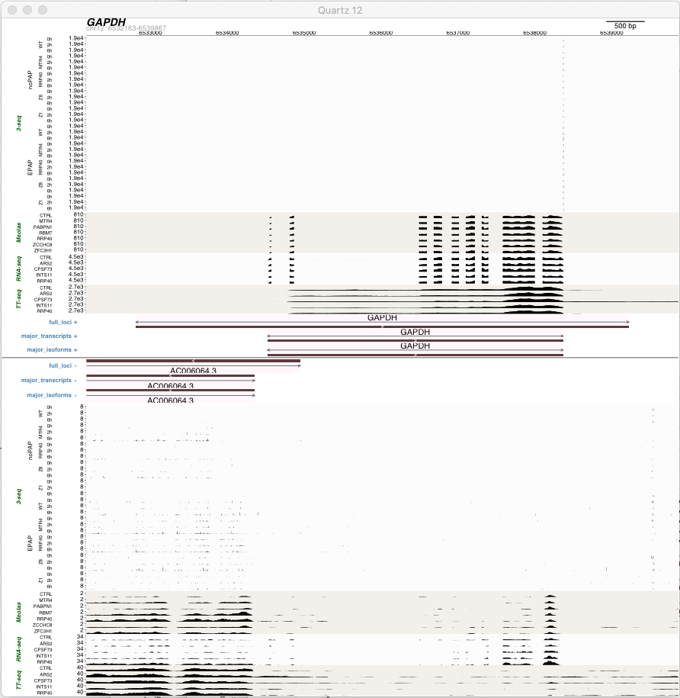

Test 32-1 – Tracks height:

- import “test import 2”
- locus ‘GAPDH’
- tracks height at 0.8
- all other parameters by default

Works as intended

Test 32-2 – Tracks height:

- import “test import 2”
- locus ‘GAPDH’
- tracks height at 0.1
- all other parameters by default

Returns an error most likely because it is too small. Maybe limit the value within the shiny app

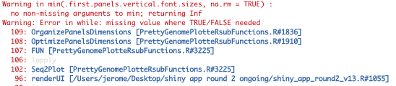

Test 32-3 – Tracks height & plot height in contradiction:

- import “test import 2”
- locus ‘GAPDH’
- tracks height at 0.8
- plot height at 10 cm
- all other parameters by default

Works as intended, plot height as priority. The features names font size still seems to be linked to tracks size and fits even less than previously.

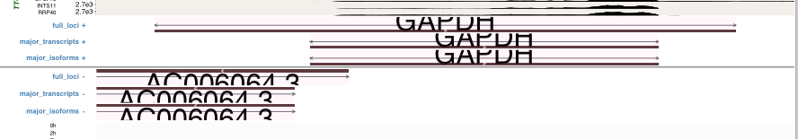

Test 33 – Change title:

- import “test import 2”
- locus ‘GAPDH’
- Changed the plot title
- all other parameters by default

Works perfectly as intended

Test 34-1 – Deactivate title display:

- import “test import 2”
- locus ‘GAPDH’
- Deactivated title display
- all other parameters by default

works perfectly as intended

Test 34-2 – Deactivate title display while providing a plot tile:

- import “test import 2”
- locus ‘GAPDH’
- Changed the plot title
- Deactivated title display
- all other parameters by default

The title gets displayed. Simply add to the shiny app parameters description that giving a title overwrite this argument. (DONE)

Test 35-1 – Plotting segments order:

- import “test import 2”
- locus ‘GAPDH’
- segment order given: “3-seq,annotations,RNA-seq,scale,TT-seq,header,Meolas”
- all other parameters by default

Works as intended (outlay is a bit weird but considering the provided input)

Test 35-2 – Plotting segments order:

- import “test import 2”
- locus ‘GAPDH’
- segment order given: “header,scale,RNA-seq,TT-seq,Meolas,3-seq,annotations”
- all other parameters by default

Works perfectly as intended

Test 35-3 – Plotting segments order:

- import “test import 2”
- locus ‘GAPDH’
- segment order given: “header,scale,RNA-seq,TT-seq,Meolas,3-seq” (thus missing annotations)
- all other parameters by default

Error: object ‘.plotting.segment.order’ not found from line 1615 from subfunction. Error is expected due the absence of ‘annotations’ but maybe make an error message.

Test 35-4 – Plotting segments order:

- import “test import 2”
- locus ‘GAPDH’
- segment order given: “﻿header,scale,RNA-seq,TT-seq,TT-seq,Meolas,3-seq,annotations” (thus having TT-seq 2 times)
- all other parameters by default

Error: graphical parameter “fig” has the wrong length from line 3074 from subfunction. Error is expected due the presence of a same dataset two times but maybe make an error message.

Test 36 – Selection of sequencing types:

- import “test import 2”
- locus ‘GAPDH’
- ticking out all datasets except RNA-seq (the colour and bw dir loaded in the environment have been adapted accordingly)
- all other parameters by default

Works perfectly as intended

Test 37-1 – Selection of samples:

- import “test import 2”
- locus ‘GAPDH’
- ticking out all the WT points of the 3-seq no PAP (the colour and bw dir loaded in the environment have been adapted accordingly)
- all other parameters by default

works perfectly as intended

Test 37-2 – Selection of samples:

- import “test import 2”
- locus ‘GAPDH’
- ticking out all the WT points of the 3-seq no PAP except the 0h MINUS but PLUS is ticked out (the colour and bw dir loaded in the environment have NOT been adapted accordingly as things are based in WhichSample)
- all other parameters by default

A plot is generated but with some errors:
X the corresponding plus strand is still displayed
X the samples naming is messed up:
- most likely because both consecutive samples now have a ‘0h’ label (Checked in the which samples that the information is well reported), this label is now centred between the WT and Mtr4 substest making things difficult to read (see picture below)
- The WT, Mtr4,… labels are now displayed horizontally (which is not a problem per se), but the Rrp40 label is truncated which should not occur with all parameters by default (issue would not have appeared if verticals labels were kept). The issue most likely arise from a considered lack of space to write ‘WT’ vertically which might not be present if the 0h label issue was not there.

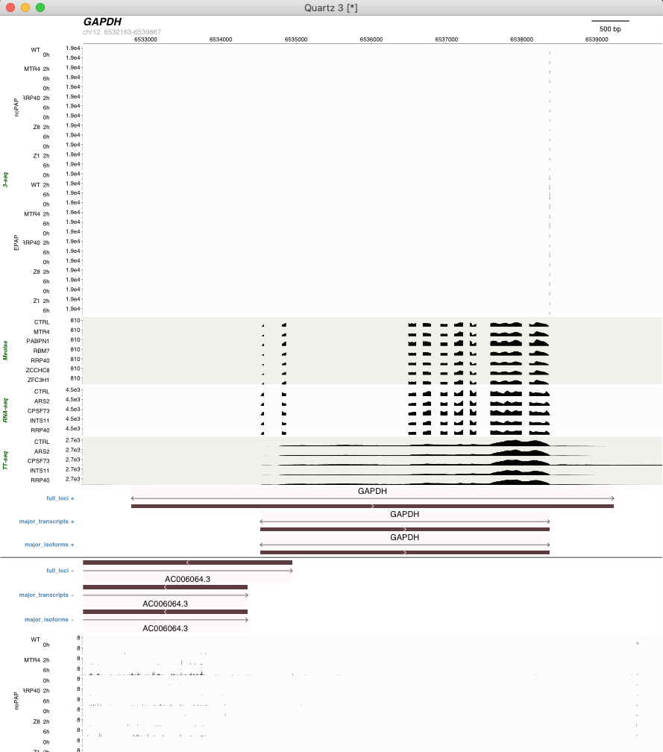

Test 38 – Selection of Seqtypes and Samples at the same time:

- import “test import 2”
- locus ‘GAPDH’
- ticking out TT-seq and all the WT points of the 3-seq no PAP (the colour and bw dir loaded in the environment have been adapted accordingly)
- all other parameters by default

works perfectly as intended.

Test 39 – Batch correction:

- import “test import 2”
- locus ‘GAPDH’
- Set batch correction to NO for RNA-seq
- all other parameters by default

seems to work as intended but difficult to visually see any difference. Will need to be tested for sturdiness in combination with removal of samples and seqtypes when both function are working.

Test 40 – Horizontal / vertical display of names:

- import “test import 2”
- locus ‘GAPDH’
- Set Vertical horizontal parameters in Shiny as: “RNA-seq:H,H;TT-seq:H,V” // Also later tried specifying all datasets “RNA-seq:H,H;TT-seq:H,V;Meolas:V,V;3-seq:V,V,V,V”
- all other parameters by default

Error line 1819: Error in if: missing values where TRUE/FALSE needed
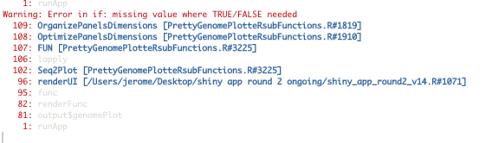

The generated input is under the form:

$`RNA-seq`
[1] TRUE TRUE

$`TT-seq`
[1] TRUE FALSE

$Meolas
[1] FALSE FALSE

$`3-seq`
[1] FALSE FALSE FALSE FALSE

Test 41 – Samples names taking all the allocated space:

- import “test import 2”
- locus ‘GAPDH’
- Setting tracks name space at 5.5 (previously worked, see test 30-2)
- setting the variable asking samples names to take the full allocated space to TRUE
- all other parameters by default

returns an error ‘invalid value specified for graphical parameter "fig"’ line 2482 of the subfunction code. Also, the beginning of display of names has the seqtype overlapping with the other names.

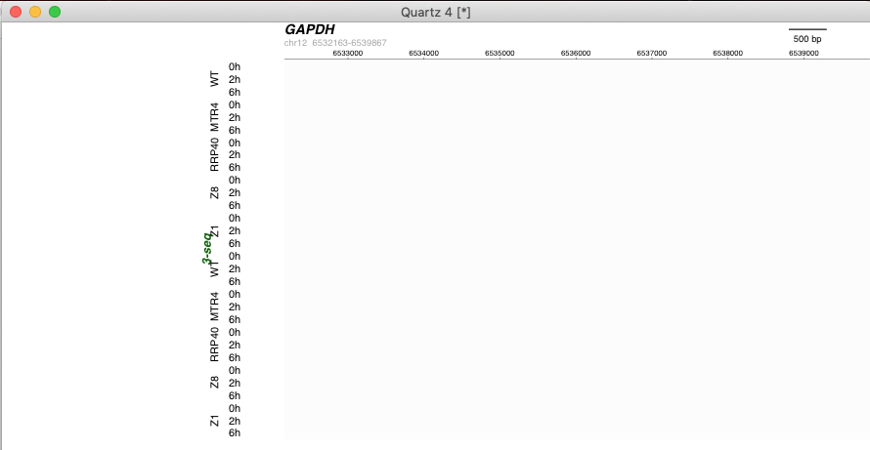

Test 42-1 – Display of samples separators:

- import “test import 2”
- locus ‘GAPDH’
- Set vertical separators to TRUE
- all other parameters by default

works as intended

Test 42-2 – Display of samples separators:

- import “test import 2”
- locus ‘GAPDH’
- Set horizontal separators to TRUE
- all other parameters by default

works as intended

Test 42-3 – Display of samples separators:

- import “test import 2”
- locus ‘GAPDH’
- Set vertical separators to TRUE
- Set horizontal separators to TRUE
- all other parameters by default

works as intended

“Test 42-4”: both negative -> the input format was still the one from previous functions until recent realisation. All test up to 54 were performed with both as FALSE.

Test 43 – Tracks subset spacing:

- import “test import 2”
- locus ‘GAPDH’
- settingof Tracks susbets spacing to FALSE
- all other parameters by default

works perfectly as intended.

Test 44 – Display only strand of interest:

- import “test import 2”
- locus ‘GAPDH’
- setting of Display only strand of interest to TRUE
- all other parameters by default

error in line 1512 of subfunctions: Error in structure: object ‘.strand’ not found.

Test 45 – Display strands as intermingled:

- import “test import 2”
- locus ‘GAPDH’
- setting of Displays strands as intermingled to TRUE
- all other parameters by default

beginning of plot gets displayed but crashes out as it reaches the point where it needs to plot the line between the plus and minus annotations and returns an error line 3050 of subfunctions: “object '.basic.plot.parameters' not found”. (I guess this parameter is only defined in the loop for not intermingled and yet is required for the line that separates both strands of annotation)

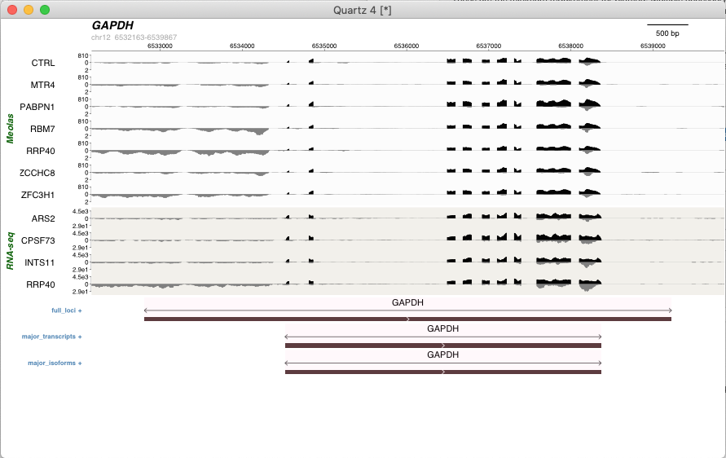

Of note, in order to have this picture (since the number of tracks is usually to big to fit in the screen), the argument had to be combined with seqtypes ans samples selections (since seqtype alone does not work), and the combination did not generate any additional issue.

Test 46 – Display negative strands as negative values:

- import “test import 2”
- locus ‘GAPDH’
- setting of Display negative strand as negative value to TRUE
- all other parameters by default

Perfectly works as intended

Test 47 – Actual strand direction:

- import “test import 2”
- locus ‘DHFR’
- setting of Actual strand direction value to TRUE
- all other parameters by default

Does not work, the plot is exactly the same weather TRUE or FALSE is provided (and DHFR is on the minus strand)

- import “test import 2”
- locus ‘ACTB’
- setting of Actual strand direction value to TRUE
- all other parameters by default

same (even if TRUE/FALSE directly provided as direct argument in the plot part of the function).

Test 48-1 – Strands opaqueness:

- import “test import 2”
- locus ‘GAPDH’
- FWD strand opaqueness to 10%
- all other parameters by default

works as intended

Test 48-2 – Strands opaqueness:

- import “test import 2”
- locus ‘GAPDH’
- REV strand opaqueness to 10%
- all other parameters by default

works as intended

Test 48-3 – Strands opaqueness:

- import “test import 2”
- locus ‘GAPDH’
- FWD & REV strand opaqueness to 30%
- all other parameters by default

works as intended

Test 49-1 Header colour:

- import “test import 2”
- locus ‘GAPDH’
- header colour set to Blue
- all other parameters by default

works perfectly as intended

Test 49-2 Header colour:

- import “test import 2”
- locus ‘GAPDH’
- header colour set to #FF0000 (red)
- all other parameters by default

works perfectly as intended

Test 49-3 Header colour:

- import “test import 2”
- locus ‘GAPDH’
- header colour set to blue,#FF0000 (red) (therefore not respecting required input format)
- all other parameters by default

plot is generated but header is black. Issue expected as instructions were not followed but maybe add an error message.

Test 50-1 Genomic scale colour:

- import “test import 2”
- locus ‘GAPDH’
- Genomic scale colour set to Blue
- all other parameters by default

works perfectly as intended

Test 50-2 Genomic scale colour:

- import “test import 2”
- locus ‘GAPDH’
- Genomic scale colour set to #FF0000 (red)
- all other parameters by default

works perfectly as intended

Test 50-3 Genomic scale colour:

- import “test import 2”
- locus ‘GAPDH’
- Genomic scale colour set to blue,#FF0000 (red) (therefore not following the rules provided)
- all other parameters by default

Error replacement has length zero in subfunction line 3144. Error expected as input format was not provided as requested but a better explanation could help.

Test 51-1 Seqtypes and samples colour:

- import “test import 2”
- locus ‘GAPDH’
- Seqtypes and samples colours set to blue
- all other parameters by default

works perfectly as intended

Test 51-2 Seqtypes and samples colour:

- import “test import 2”
- locus ‘GAPDH’
- Seqtypes and samples colours set to blue,#FF0000 (red)
- all other parameters by default

works perfectly as intended

Test 51-3 Seqtypes and samples colour:

- import “test import 2”
- locus ‘GAPDH’
- Seqtypes and samples colours set to blue,#FF0000,green (red) (therefore not following the rules provided)
- all other parameters by default

The plotting is done but all labels are black. Issue expected as input format was not provided as requested but a better explanation could help.

Test 52-1 Genomic annotations names colour:

- import “test import 2”
- locus ‘GAPDH’
- Genomic annotations names colour set to Green
- all other parameters by default

works perfectly as intended

Test 52-2 Genomic annotations names colour:

- import “test import 2”
- locus ‘GAPDH’
- Genomic annotations names colour set to #FF0000 (red)
- all other parameters by default

works perfectly as intended

Test 52-3 Genomic annotations names colour:

- import “test import 2”
- locus ‘GAPDH’
- Genomic annotations names colour set to blue,#FF0000 (red) (therefore not following the rules provided)
- all other parameters by default

Error replacement has length zero in subfunction line 3144. Error expected as input format was not provided as requested but a better explanation could help.

Test 53-1 Loci names colour:

- import “test import 2”
- locus ‘GAPDH’
- Loci names colour set to Green
- all other parameters by default

works perfectly as intended

Test 53-2 Loci names names colour:

- import “test import 2”
- locus ‘GAPDH’
- Loci names colour set to #FF0000 (red)
- all other parameters by default

works perfectly as intended

Test 53-3 Loci names colour:

- import “test import 2”
- locus ‘GAPDH’
- Loci names colour set to blue,#FF0000 (red) (therefore not following the rules provided)
- all other parameters by default

Error replacement has length zero in subfunction line 3149. Error expected as input format was not provided as requested but a better explanation could help.

Test 54-1 Sequencing tracks scale colour:

- import “test import 2”
- locus ‘GAPDH’
- Sequencing tracks scale colour set to blue
- all other parameters by default

works perfectly as intended

Test 54-2 Sequencing tracks scale colour:

- import “test import 2”
- locus ‘GAPDH’
- Sequencing tracks scale colour set to #FF0000 (red)
- all other parameters by default

works perfectly as intended

Test 54-3 Sequencing tracks scale colour:

- import “test import 2”
- locus ‘GAPDH’
- Sequencing tracks scale colour set to blue,#FF0000 (red) (therefore not following the rules provided)
- all other parameters by default

Error replacement has length zero in subfunction line 3146. Error expected as input format was not provided as requested but a better explanation could help.

Test 55-1 Sequencing tracks separators colour:

- import “test import 2”
- locus ‘GAPDH’
- Sequencing tracks separators colour set to blue
- all other parameters by default

works perfectly as intended. Of note, it seems that the color of the horizontal separator of the annotations strands is based on this.

Test 55-2 Sequencing tracks separators colour:

- import “test import 2”
- locus ‘GAPDH’
- Sequencing tracks separators colour set to #FF0000 (red)
- all other parameters by default

works perfectly as intended. Of note, it seems that the color of the horizontal separator of the annotations strands is based on this.

Test 55-3 Sequencing tracks separators colour:

- import “test import 2”
- locus ‘GAPDH’
- Sequencing tracks separators colour set to blue,#FF0000 (red) (thus not following instruction)
- all other parameters by default

Plot get drawn without any vertical spacer. Issue expected as format was not followed. Maybe add an error message.

Test 56-1 Sequencing tracks separators thickness:

- import “test import 2”
- locus ‘GAPDH’
- Sequencing tracks separators thickness set to 20
- all other parameters by default

works perfectly as intended. Very big and covers most of the text, maybe add a warning message

Test 56-2 Sequencing tracks separators thickness:

- import “test import 2”
- locus ‘GAPDH’
- Sequencing tracks separators thickness set to 0.1
- all other parameters by default

works perfectly as intended.

Test 56-3 Sequencing tracks separators thickness combined with horizontal separators:

- import “test import 2”
- locus ‘GAPDH’
- Sequencing tracks separators thickness set to 20
- set horizontal separators to TRUE
- all other parameters by default

works perfectly as intended. Very big and covers most of the text for the vertical ones, maybe add a warning message. Horizontal ones seems to have a max which is good.

Test 57 – 1 Header font size:

- import “test import 2”
- locus ‘GAPDH’
- Header font size set to 50
- all other parameters by default

works perfectly as intended. Too big to fit properly, maybe add a warning.

Test 57 – 2 Header font size:

- import “test import 2”
- locus ‘GAPDH’
- Header font size set to 1
- all other parameters by default

works perfectly as intended. Very small, maybe add a warning.

Test 58-1 Genomic scale font size:

- import “test import 2”
- locus ‘GAPDH’
- Genomic scale font size set to 50
- all other parameters by default

generates an error missing value where TRUE FALSE needed at line 2379 of the subfunction

Test 58-2 Genomic scale font size:

- import “test import 2”
- locus ‘GAPDH’
- Genomic scale font size set to 8
- all other parameters by default

Works perfectly as intended

Test 59-1 Minimum tracks names font sizes:

- import “test import 2”
- locus ‘GAPDH’
- Minimum tracks names font size set to 25
- all other parameters by default

generates an error missing value where TRUE FALSE needed at line 1836 of the subfunction

Test 59-1 Minimum tracks names font sizes:

- import “test import 2”
- locus ‘GAPDH’
- Minimum tracks names font size set to 10
- all other parameters by default

generates an error missing value where TRUE FALSE needed at line 1836 of the subfunction

Test 60-1 simplistic definition of sequencing names font size:

- import “test import 2”
- locus ‘GAPDH’
- sequencing names font size set to 15 (one number for all)
- all other parameters by default

works perfectly as intended. Names too big to fit in the boxes, maybe add a warning

Test 60-2 simplistic definition of sequencing names font size:

- import “test import 2”
- locus ‘GAPDH’
- sequencing names font size set to 15,3 (two numbers for all)
- all other parameters by default

works perfectly as intended. Seqtypes names too big to fit in the boxes, maybe add a warning

Test 60-3 simplistic definition of sequencing names font size:

- import “test import 2”
- locus ‘GAPDH’
- sequencing names font size set to 15,10,8,3 (larges number of subsettings for all)
- all other parameters by default

works perfectly as intended. Names too big to fit in the boxes, maybe add a warning

Test 60-4 simplistic definition of sequencing names font size:

- import “test import 2”
- locus ‘GAPDH’
- sequencing names font size set to 3,12 (two numbers for all but none decreasing)
- all other parameters by default

works perfectly as intended. Names too big to fit in the boxes, maybe add a warning

Test 61 Extended definition of sequencing names font size:

- import “test import 2”
- locus ‘GAPDH’
- sequencing names font size set to “RNA-seq:12,9;3-seq:12,10,8,6” (shiny input format)
- all other parameters by default

works perfectly as intended. Names too big to fit in the boxes, maybe add a warning

Test 62-1 Annotations names font size:

- import “test import 2”
- locus ‘GAPDH’
- Annotations names font size set to 50
- all other parameters by default

works perfectly as intended. Names too big to fit in the boxes, maybe add a warning

Test 62-2 Annotations names font size:

- import “test import 2”
- locus ‘GAPDH’
- Annotations names font size set to 1
- all other parameters by default

works perfectly as intended. Names very small, maybe add a warning

Test 63-1 Annotations features names font size:

- import “test import 2”
- locus ‘GAPDH’
- Annotations features names font size set to 4 (minimum allowed)
- all other parameters by default

works perfectly as intended.

Test 63-2 Annotations features names font size:

- import “test import 2”
- locus ‘GAPDH’
- Annotations features names font size set to 50
- all other parameters by default

generates an error: missing value where TRUE/FALSE needed at line 1836 of the subfunctions..

Test 63-3 Annotations features names font size:

- import “test import 2”
- locus ‘GAPDH’
- Annotations features names font size set to 20
- all other parameters by default

works perfectly as intended. Big names do not fit the display, maybe add a warning.

Test 64-1 Scale font size:

- import “test import 2”
- locus ‘GAPDH’
- Scale font size set to 4 (minimum)
- all other parameters by default

works perfectly as intended.

Test 64-2 Scale font size:

- import “test import 2”
- locus ‘GAPDH’
- Scale font size set to 5 (maximum)
- all other parameters by default

works perfectly as intended.

Test 65 – Deactivated tracks scales display:

- import “test import 2”
- locus ‘GAPDH’
- Set tracks scale display to FALSE
- all other parameters by default

works perfectly as intended

Test 66-1 – Manual scaling:

- import “test import 2”
- locus ‘GAPDH’
- Set manual scaling to “RNA-seq:200,TT-seq:400,3-seq:2,Meolas:2000” (shiny input format)
- all other parameters by default

works perfectly as intended.

Test 66-2 – Manual scaling:

- import “test imp’ort 2”
- locus ‘GAPDH
- Set manual scaling to “RNA-seq:200,TT-seq:400” (shiny input format), while 2 other dataset are present (therefor not respecting indicated input format)
- all other parameters by default

starts to plot and generates an error missing value where TRUE/FALSE needed at line 2723 of the subfunction. Error was expected as input format was not respected, maybe add a corresponding warning.

Test 67-1 – Scale display size:

- import “test import 2”
- locus ‘GAPDH’
- Set the allocated space for scale to 0.2
- all other parameters by default

works perfectly as intended.

Test 67-2 – Scale display size:

- import “test import 2”
- locus ‘GAPDH’
- Set the allocated space for scale to 0.000005
- all other parameters by default

most likely technically works but due to the very small size, the scale is not visible, and it also somehow also reduced dramatically the size of the annotations name. Due to lack of space? Maybe limit value in Shiny app.

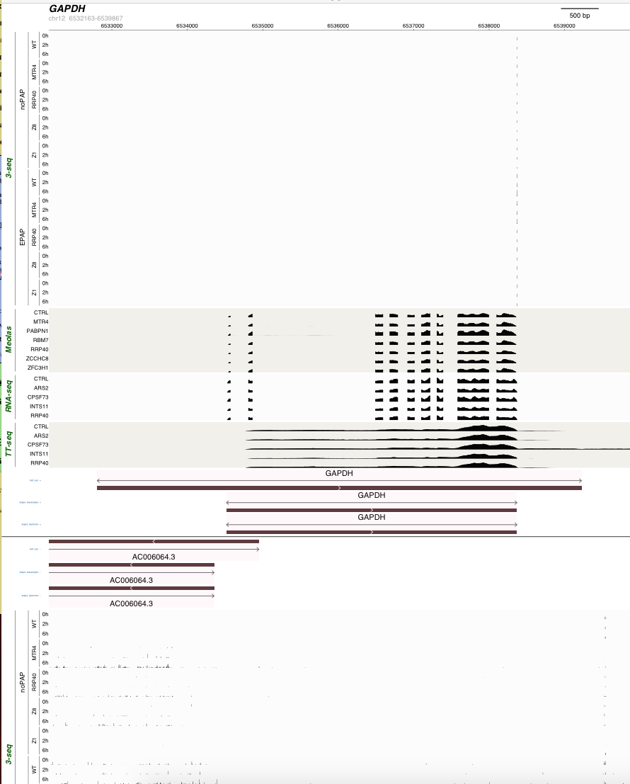

Test 68 – Deactivate genomic scale:

- import “test import 2”
- locus ‘GAPDH’
- Deactivate display of genomic scale
- all other parameters by default

works perfectly as intended.

Test 69 – 1 Genomic scale display below the plot:

- import “test import 2”
- locus ‘GAPDH
- Genomic scale display on top = FALSE
- Had to be combined with removal of 3-seq for the plot to fit in the screen
- all other parameters by default

Works perfectly as intended

Test 69 – 2 Genomic scale display below the plot while deactivating its display:

- import “test import 2”
- locus ‘GAPDH’
- Deactivate display of genomic scale
- Genomic scale display on top = FALSE
- Had to be combined with removal of 3-seq for the plot to fit in the screen
- all other parameters by default

Works perfectly as intended

